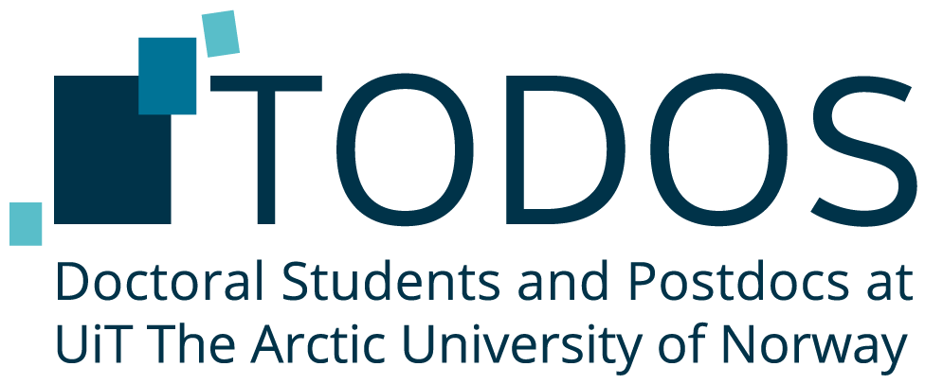
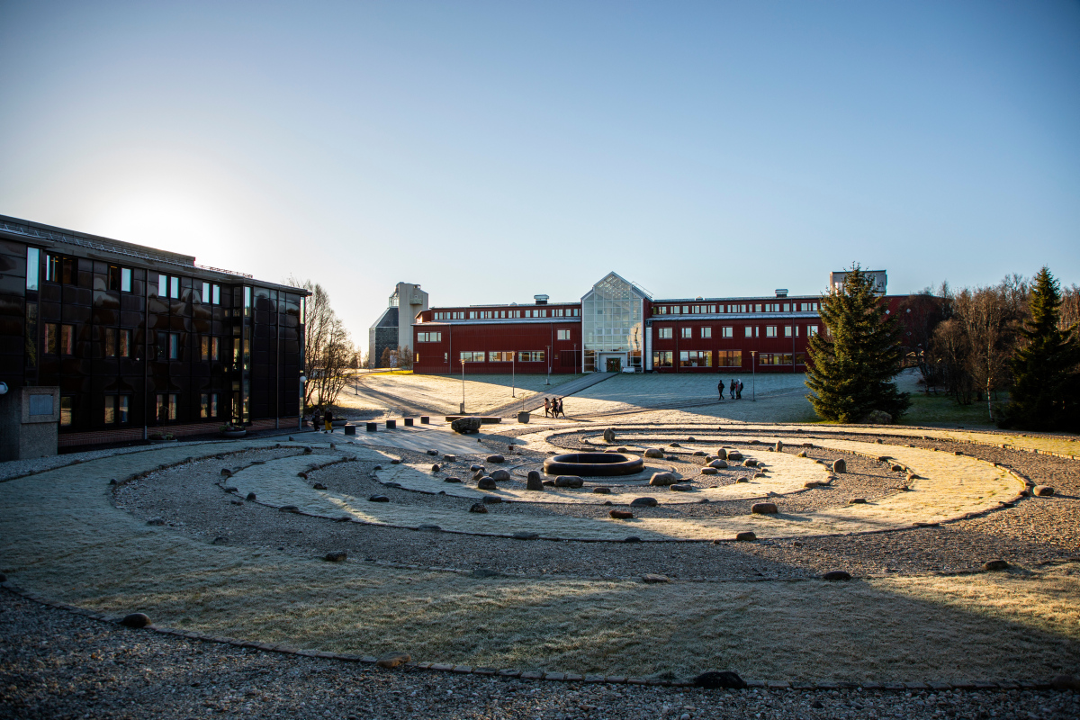

Annual Report 2024
Email: todos@uit.no
Web: todos.uit.no
Facebook: ww.facebook.com/TodosUiT
Foto: David Jensen
Contents

Contents 1
Note from the Board Chair 2
What is TODOS? 3
The 2024 TODOS Board 4
Board work 4
Advocacy and outreach 5
Social events 5
Academic events 6
SiN Annual General Meeting 6
Communication channels 6
Spending 2024 6
Provisional budget 2025 8
The Way Forward 8

Note from the Board Chair
Dear PhD candidates and PostDocs at UiT,
As we approach the end of 2024, I am happy to present to you TODOS annual report. It’s a good time to look back and reflect on the TODOS Board activities and look forward to ambitions for 2025.
During the spring semester of 2024 operations were slow due to unforeseen circumstances, travel and absence of Board members. Despite these challenges The Board worked hard to put together successful academic and social events. The fall semester brought enthusiastic new Board members to the positions of Vice Chair, Academic and Social affairs.
Looking forward to 2025 the Board hopes to continue the staple academic events at Tromsø campus including the Three Minute Thesis Competition and the Writing Retreat. TODOS will continue with social events to create spaces for PhDs and PostDocs to interact outside of their research and work. How UiT responds to the changes to Norwegian language requirements for PhD and PostDocs (which came into effect 1. Aug 2024) will be an important task for the Board in 2025.
Representation of all campuses will continue the agenda of the TODOS Board. Currently, planning is underway for Board members from Tromsø to visit other campuses. I hope that it will be possible to recruit and maintain campus representatives who will use the available budget to organise TODOS activities across all campuses.
I feel it is important to continue to ensure that TODOS is visible across all campuses and faculties, but most importantly, to the PhD candidates and postdoctoral fellows. TODOS as an organisation is here to represent and support this group of staff at UiT The Arctic University of Norway. Representing TODOS at staff welcome and information events across all campuses will continue to be important work.
I would like to thank all member of the TODOS Board for their excellent work the past year, and all PhDs and PostDocs who have participated in TODOS activities and events. I wish you all well during the holiday season, and hope 2025 brings a motivated TODOS Board.

Warm Regards,
Alexandra Abrahams
TODOS Board Chair 2024

What is TODOS?
Doctoral Students and Postdocs at UiT The Arctic University of Norway (TODOS) is an interest organization for PhD candidates & PostDocs at UiT. We focus on three important aspects of being a successful PhD candidate & postdoc: good academic work environment, healthy social life, and representation of our interests in various university boards and committees. Every semester we organise multiple academic events and social gatherings, spanning the Narvik, Harstad, Tromsø and Alta campuses. Through this, we hope to contribute to improving your PhD & postdoc experience.

The 2024 TODOS Board
The TODOS board for the spring of 2024:
Board Chair | Alexandra Abrahams
Vice Chair | Mizanur Rahman
Treasurer | Claire Degail
Chair of Academic Affairs | -
Chair of Social Affairs | Shemin Sagaria
Chair of Communications  Alta representative | Tiziana Durazzano  Alessia Marzano

The TODOS board for the autumn of 2024:
Board Chair | Alexandra Abrahams
Vice Chair | Shannon Moore
Treasurer | Claire Degail
Chair of Academic Affairs | Juliana Tatara
Chair of Social Affairs | Lina Würfel
Chair of Communications | Waranya Wataniyakun

The following positions are open for the December 2024 elections:
- Board Chair
- Treasurer
- Chair of Academic Affairs
In addition to these positions, the next Board will work to recruit campus representatives in 2025 for Alta, Harstad, and Narvik.

Board work

Advocacy and outreach
TODOS has the important task of advocacy and outreach regarding PhD and PostDoc matters at UiT. In 2024 TODOS was represented at a number of Boards and meetings across UiT including:
- The Committee on Research Strategy (forskningsstrategisk utvalg)
- The High North Academy steering board
- UiT Prize Committee
TODOS has been invited to present at a number of welcome to new PhD candidate events (newly employed foreign staff, Changing Arctic Research School welcome week, iC3 new PhD) and the PhD day at the Library. The Board is very thankful for the invitations and hopes to grow the network across faculties to ensure PhD and PostDocs know about TODOS.
Ensuring PhDs and PostDocs are informed of important issues is a crucial task of the TODOS Board. This year there were a number of important changes to regulations in Norway that effect TODOS members, including:
- Temporary employees are now eligible for contract extension for sick-leave including sick leave under 2 weeks due to amendment from the Ministry of Education and Research employment regulations section § 2-3, fifth paragraph
- PhDs and PostDocs who cannot document A2 level Norwegian language must take Norwegian classes corresponding to at least 15 points within the period they take their PhD
  - «Dersom den ansatte ikke kan dokumentere ferdigheter i norsk, svensk eller dansk på nivå A2 ved ansettelse, skal institusjonen tilby norskopplæring….Den ansatte skal gjennomføre opplæring tilsvarende minst 15 studiepoeng innen utløpet av åremålsperioden.» (https://lovdata.no/dokument/SF/forskrift/2024-06-28-1392/kap3#kap3)
- The period PostDocs now have to complete their position has been increased from two to three years
  - « I universitets- og høyskoleloven § 7-6 er minimum åremålsperiode for en postdoktor økt fra to til tre år. Åremålsperioden skal være tre til fire år. Utlysningene med frist fra og med 2024 angir minimumskravet for postdoktorer på tre år. » (https://www.forskningsradet.no/finansiering/hva/postdoktorstipendiatstilling/)

Social events
Shemin (spring Chair of Social Affairs) organised a number of well attended events including games night, minigolf, and bowling. Lina (autumn Chair of Social Affairs) has organised a HUGE number of amazing events including speed friending, film at Verdensteatret, game night, bowling, and the upcoming julebord.

Academic events
In spring, TODOS organised for the first time a 3 Minute Thesis Competition. This event was a large success and the Board received great feedback from the participants. TODOS plans to host this event again in spring semester 2025. Thank you to Shemin (spring Vice Chair) for organizing this event, and special thanks to our two judges Mari Buck and Marcela Douglas Aranibar. Congratulations to the winners Srijana Bastakoti, Mahith Madhanakumar, and Eva Chamorro Garrido and a big round of applause to the other 6 participants!
The writing retreat took place again at Malangen Resort in November. Unfortunately, there was no writing retreat in spring semester due to the Chair of Academic Affairs position vacancy. A total number of 18 PhD candidates from a range of faculties joined for a successful and productive retreat.

SiN Annual General Meeting
At this year’s SiN (Stipendiat i norge) Annual General Meeting, Vice Chair Shannon Moore represented TODOS. Many important issues were discussed at the meeting, all of which were extensions of conversations that have been happening throughout the year. These include the recent language requirements put into law, the recent restriction of temporary positions, and mental health concerns to name a few. SiN has been very involved in responding to formal calls for feedback from the government, writing position statements on matters of high importance for PhDs and PostDocs, and increasing visibility through opinion pieces and articles on Norwegian news platforms. Our own Treasurer, Claire Degail, was re-elected as Vice President for SiN at this year’s meeting. In TODOS, we have now established that it will be the Vice Chair’s responsibility to remain updated on SiN information and calls for feedback to better connect TODOS to other PhDs and PostDocs across Norway.

Communication channels
The Board has been engaged in ongoing conversation regarding the best way of reaching and engaging PhDs and PostDocs. Due to challenges with email lists, Chair of Communications has been working hard to ensure all updated information is posted on TODOS webpage. We apologise to those who have not been receiving emails and endeavour to improve TODOS communications situation in the new year.

Spending 2024
Spending for 2024 is under budget, mainly due to difficulties in engaging representative at campuses other than Tromsø. The reserve assets from the 2023 Board of 75 000 kr has not been accounted for in this budget, as records of TODOS assets was unable to be attained. This also has led to the back-payment of previous Board members being covered under this 2024 budget.
Income (Inntekter)
Budget from UiT | 450,000.00
Assets from 2023 | ?
Income and assets | Budgeted | Actual expenses
Operating Costs (Driftskostnader)
Board Members Compensation (Styrekompensasjon) | 150,000.00 | 150,000.00
Compensation catch up (unpaid from previous year) | 50,000 | 50,000
SiN membership (Kontingent SiN) | 6,000.00 | 6,000.00
Promotional items (Marketing, goodies) | - | -
Meeting costs (Møtekostnader) + team building | 2,800.00 | 2,220.00
Travelling Costs (Reisekostnader) | 2,000.00 | -
TOTAL Operating Costs | 210,800.00 | 208,220.00
Bi-Annual Meetings
Summer Election BBQ | 1,348.00 | 1,348.00
Winter Election & Julebord | 30,000.00 | 18,163.00
TOTAL Bi-annual Meetings | 31,348.00 | 19,511.00
Academic Events
Three Minute Thesis (April) | 10,805.00 | 10,805.00
1 Writing Retreat (Nov/Dec) | 85,748.00 | 85,748.00
TOTAL Academic Events | 96,553.00 | 96,553.00
Social Events
Diverse social events | 15,000.00
Bowling February 2024 |  | 4,687.00
September welcome meeting |  | 4,445.00
Kino September 2024 |  | 2,600.00
Minigolf/Bowling |  | 3,600.00
TOTAL Social Events | 15,000.00 | 15,332.00
Inclusion of other Campuses
TODOS representatives (x3) | 30,000.00
Harstad jan 2023 jan 2024 |  | 10,000.00
Narvik Jan 2023 Jan 2024
Alta Jan 2023 Jan 2024
Activities in Alta, Harstad, Narvik | 30,000.00
Travel costs for board members | 30,000.00
TOTAL Inclusion of other Campuses | 90,000.00 | 10,000.00
 | Budgeted | Actual Expenses
 | 443,701.00 | 343,616.00

Provisional budget 2025
The following is an outline of our provisional budget for 2025, by main expense categories. The budget leaves a buffer of 19,000.00kr which may be allocated to organise events to compensate for increasing costs. For more details, see the full provisional budget on the website.
Operating costs (incl. board compensation) | 161 000
Bi-annual meetings (summer, Christmas) | 40 000
Academic events | 100 000
Social events | 40 000
Inclusion of other campuses | 90 000
Total | 431 000

The Way Forward
A huge thankyou again to all Board members from 2024, my time as Chair of TODOS has been enjoyable and productive. As Chair I am working to create good hand over documentation for smooth transition of positions. I hope you all enjoy the holiday period, and am excited for what TODOS has to bring in 2025.

