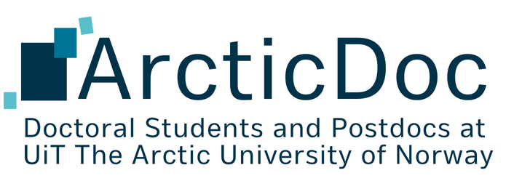
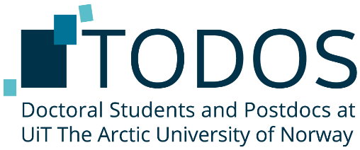
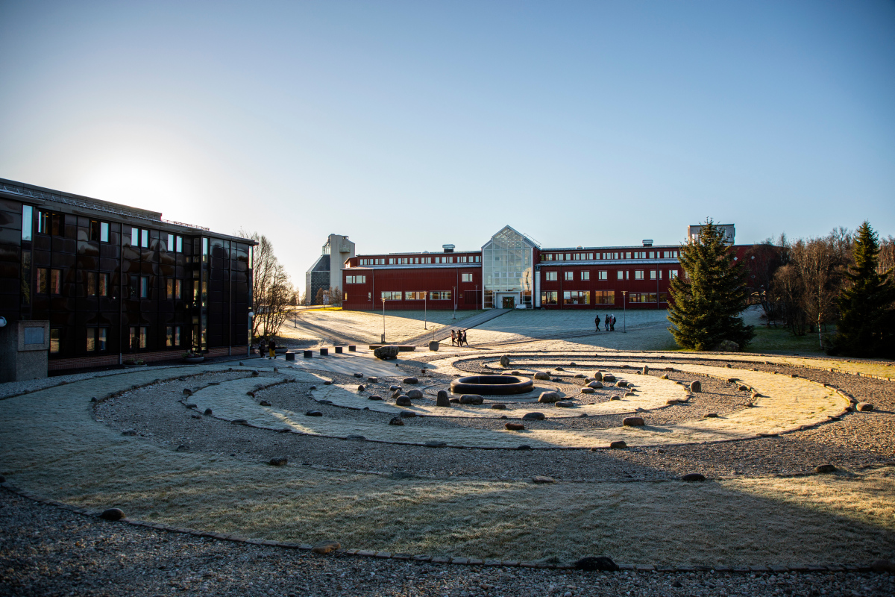

Annual Report 2025
Email: todos@uit.no
Web: todos.uit.no
Facebook: ww.facebook.com/TodosUiT
Foto: David Jensen
Contents

Note from the Board Chair 3
What is ArcticDoc? 4
The 2025 ArcticDoc Board 4
Board work 5
Advocacy and outreach 5
Social events 6
Academic events 6
SiN Annual General Meeting 6
Communication channels 6
Spending 2025 7
Provisional budget 2026 8
The Way Forward 9

Note from the Board Chair
Dear PhD candidates and PostDocs at UiT,
As we approach the end of 2025, I am happy to present to you the ArcticDoc annual report. It’s a good time to look back and reflect on the ArcticDoc Board activities and look forward to ambitions for 2026 and beyond.
2025 has been filled with diverse ArcticDoc activities brought to life thanks to the committed Board members. I am very grateful to have worked alongside these amazing fellow PhD candidates.
The current Board has been preparing ArcticDoc for a makeover: in 2026 we are excited to welcome ArcticDoc to life! The current ArcticDoc Board has deliberated, asked for input at the previous two General Meetings, and unanimously decided that it is time to breathe new life into the organisation.
The current Board believes that ArcticDoc will communicate more clearly what the organisation is here for: representing and supporting PhDs and Postdocs, both international and Norwegian, enhancing their welfare and success. ArcticDoc’s mission continues to be the same: Improving the academic environment and social life, ensuring a balanced and enriching PhD and Postdoc experience across all campuses of UiT The Arctic University of Norway.
ArcticDoc was chosen to be representative and inclusive of all campus locations, and with the addition of a 6-month Campus Engagement position we hope to increase awareness and presence of ArcticDoc across all locations and recruit active campus representatives. The Board has worked to plan the transition to go as smoothly as possible and thank you for your patience through the process.
I would like to again thank all members of the ArcticDoc Board for their excellent work the past year, and big thank you to all PhDs and PostDocs who have participated in ArcticDoc activities and events over the past year. I wish you all well during the holiday season, and with the new ArcticDoc Board all the best for 2026.

Warm Regards,
Alexandra Abrahams
ArcticDoc Board Chair 2025

What is ArcticDoc?
ArcticDoc is an interest organization for doctoral students and postdocs at UiT The Arctic University of Norway. We focus on three important aspects of being a successful PhD candidate & postdoc: good academic work environment, healthy social life, and representation of our interests in various university boards and committees. Every semester ArcticDoc organise academic events and social gatherings across Alta, Harstad, Narvik and Tromsø campuses. Through this, the ArcticDoc Board hope to contribute to enriching and improving your PhD and postdoc experiences.

The 2025 ArcticDoc Board
The ArcticDoc Board for the spring of 2025:
Board Chair | Alexandra Abrahams
Vice Chair | Shannon Moore
Treasurer | Claire Degail
Chair of Academic Affairs | Shemin Sagaria
Chair of Social Affairs | Lina Würfel
Chair of Communications | Waranya Wataniyakun
Narvik representative | Laura-Kristin Scholtz

The ArcticDoc Board for the autumn of 2025:
Board Chair | Alexandra Abrahams
Vice Chair | Shannon Moore
Treasurer | Claire Degail
Chair of Academic Affairs | Shemin Sagaria
Chair of Social Affairs | Lina Würfel
Chair of Communications | Edvard Lia
Narvik representative | Laura-Kristin Scholtz

The following positions are open for the December 2025 elections:
- Board Chair
- Treasurer
- Chair of Academic Affairs
- Campus Representatives: Alta, Harstad, Narvik
- Campus Engagement
Campus Engagement is a new temporary position to focus on building awareness of and increasing engagement with ArcticDoc across all campuses!

Board work

Advocacy and outreach
ArcticDoc has the important task of advocacy and outreach regarding PhD and PostDoc matters at UiT. In 2025 ArcticDoc was represented at several boards and meetings across UiT including:
- The Committee on Research Strategy (forskningsstrategisk utvalg)
- The High North Academy steering board
- UiT Prize Committee
- Annual UiT PhD Meeting
- Monthly meeting with the administrative coordinator for the PhD program (Nina Norum Anda)
This past January, ArcticDoc and the administrative coordinator for the PhD program (Nina Norum Anda) began having monthly meetings. These meetings have developed into a space to discuss pressing PhD issues and to help sort out some of the uncertainty around the operations of ArcticDoc and our budget. It has also proven to be a useful space to talk through the ARK results and supplement those results with personal testimony from PhDs and PostDocs. These meetings have helped close the gap between higher administration bureaucracy and the everyday experiences of PhDs and PostDocs. We are looking forward to continuing this close relationship.
A new meeting space at the higher administrative level being introduced next year is the strategisk doktorgradsutvalget (Strategic Doctoral Committee). The motivation behind creating this new committee stems from the annual UiT PhD meetings that occur in January and the feeling that there was not enough time in this one meeting to address all the concerns brought up and develop solutions. While there are still some uncertainties pertaining to this new committee, ArcticDoc is hoping to help shape the discussions based on the input we receive from the PhDs at UiT to help organize PhD programs better and help streamline regulations and information in a more accessible manner.
ArcticDoc has been invited to present at several welcome events for new PhD candidate, specifically the event for newly employed foreign staff, Changing Arctic Research School welcome week, new PhDs at iC3, and the the Orienteringsmøte for PhDs at the Law Faculty. We have also been present at the PhD day at the University Library. The Board is very thankful for these invitations and hopes to grow the network across all faculties at UiT to ensure PhD and PostDocs know about ArcticDoc and the support and resources we provide.

Social events
Lina introduced a new concept “Social Thursdays” in the spring semester. The aim was to meet up regularly, e.g. once a month, at the same place and arrange for people to bring board games, knitting project or just come and talk. We had pizza during one event per semester. We met up at gammelkantina in Breiviklia throughout the whole year. The dates were announced in the start of the semester via the newsletter and posters were put on the TVs spread around campus. Lina also sent out reminders in the WhatsApp group. Surprisingly, there were both ‘regulars’ and new people every time. Lina will continue this concept during the spring semester as it is easily arranged and has a good turnout (between 7 and 20 participants per meeting).
In addition to the Thursday social, a variety of events was arranged. During the spring semester, we had an evening at a bowling alley and a summer party. In the winter, we met for two paint on ceramics-events. The first one was fully booked within five hours, so we arranged one more two days later to give everyone who wanted to come the chance to come (40 participants in total). We also went to the Pust sauna for some wellness and everyone seemed to have a great time (19 participants). For the last Thursday social, we ordered pizza and collaborated with the library on some LEGO-building (20 participants).
The year concluded with the Christmas party which we decided to arrange at the same time as the general meeting to attract more participants, better feedback and improved decision-making. As a contrast from last year, Lina decided to book tables at EPIC Tromsø. They served a Christmas dinner and provided shuffleboards and darts after dinner (50 participants).
Lina wants to thank everyone who came to any of the events during this year for joining! It was great to see how well people responded to the different events and she is looking forward to next semester!

Academic events
The activities under the Chair of Academic Affairs focused on supporting the academic development of PhD and postdoctoral students, fostering opportunities for research and writing skill enhancement, and strengthening collaboration with institutional units such as the library and teaching development offices. The position’s objectives included designing events and workshops to build both academic and transferable skills, promoting peer engagement, and contributing to the overall scholarly environment within the organisation.
Throughout the year, several key activities were successfully carried out. We organised four sessions of Penning the Research, providing structured time and space for participants to focus on their writing and make progress on their research projects. In addition, we held a Peer Review with a Kaffe session, creating a supportive environment where participants could receive feedback on their work while fostering academic discussion. We also conducted a 3-Minute Presentation (3MT) competition, allowing participants to present their research succinctly and develop skills in clear communication and public speaking. These events were well received, with participants reporting improvements in writing efficiency, presentation skills, and engagement with peers.
Beyond these completed activities, I have also initiated action to organise several programs and proposals intended to enrich the academic experience of PhD students in the future. These initiatives include a Skill Swap session, where students can teach and learn various skills from each other. Further, we worked on organising an online webinar series focusing on personal growth, mental well-being, and professional development. Further collaboration discussions are ongoing with RESULT and the library proposing for a Write Week and other joint events, allowing multiple academic development activities to take place in a consolidated timeframe. The proposed projects include a Long Night Writing session, a PhD Day, and a series of webinars on time management are under consideration. In addition, discussions to plan workshops on developing a teaching portfolio and academic leadership are ongoing, while collaborations with the High North Academy aim to explore off-campus academic writing retreats, similar to a writing retreat format previously conducted, and potentially integrating course tools into library writing desks. Ideas for credit-bearing programs, gamification in teaching, and data interpretation competitions were topics of discussion as ways to enhance engagement and skill-building.
These efforts reflect a proactive approach to expanding the scope of academic support and innovation within ArcticDoc. Overall, this period has been marked by both the successful execution of core academic support events and the strategic development of future programs aimed at fostering a robust, collaborative, and skill-enhancing environment for graduate researchers. Moving forward, continued focus on collaboration, creative programming, and responsiveness to student needs will remain central to the role of Chair of Academic Affairs.

SiN Annual General Meeting
At the Annual General Meeting on 22 November, a new SiN board was elected, with gender balance and members from three different universities (NTNU, UiO and OsloMet). Several elements in the statutes were also amended. One important change is that the EURODOC Liaison Officer is now elected for one year instead of two. The recommendation that the board should have an odd number of members is removed, and it is now possible for board positions to be filled by candidates who are not represented by one of the local organizations, provided the Annual General Meeting supports this. The position title “UHR representative” is replaced with “Head of Government Relations.” It is also clarified that, during the Annual General Meeting, the board may be expanded to up to nine members.
Claire Degail, treasurer of ArcticDoc, is now leaving the SiN board and is grateful for her role as Vice Chair from 2023–25. A focus over the past two years has been to strengthen cooperation among the member organizations through regular contact and meetings. In 2025 SiN introduced a new scheme aimed at the member organizations: funding for events that are relevant for early-career researchers and can be shared with other organizations (webinars, digital recordings, etc.).
The period has also been marked for SiN by discussions on several important issues, including the removal of the A2-level Norwegian language requirement for research fellows, differences in compensation for board members and in the budgets across the various member organizations, cuts in the recruitment of PhDs, the working environment in academia, and the relationships between research fellows and supervisors.

Communication channels
The Board has been engaged in ongoing conversation regarding the best way of reaching and engaging PhDs and PostDocs. Due to challenges with email lists, Chair of Communications has been working hard to ensure all updated information is posted on ArcticDoc webpage. We apologise to those who have not been receiving emails and endeavour to improve ArcticDoc communications situation in the new year.
In the spring, we started sending out newsletters on a regular basis, which has continued throughout the fall semester. The newsletters are intended to function as a hub of information for members about upcoming events, courses, surveys, and any other miscellaneous stuff relevant to our members. Currently, there is no set schedule for how often the newsletters are sent out, but the frequency is about 3-4 newsletters per semester.
The website has been kept up to date, with a newly added section on the home page with brief information about upcoming events. This is intended to function as a quick way for our members to keep up to date with what’s going on without needing to trawl through their inboxes. In 2025, we also started added the board meeting minutes to the website so our members can keep track of what the board is doing behind the scenes. With the name change from TODOS to ArcticDoc, we have initiated the process of changing our email address and website to better reflect the new name.
Apart from our main channels (email, website, newsletter), we have also advertised our events on Tavla, Facebook and the info screens on Campus Breivika on a semi-regular basis.
Campus Engagement
Campus engagement has been low over the past year of ArcticDoc operations. We have had representation at Narvik campus by Laura-Kristin Scholtz, but have lacked representatives for Alta and Harstad campus. This has resulted in unspent budget allocated to campus engagement. Moving forward in 2026 the ArcticDoc board has created a new temporary position to work on improving in this area: Campus Engagement. The intention for this position is to use the campus representative budget to allow the elected Campus Engagement Board member to travel to other campuses to increase awareness of ArcticDoc and the opportunities available to PhDs and Postdocs across all campuses.
Narvik campus
In 2025, Campus Narvik was represented at the board meetings by a local campus representative (Laura). Laura was able to attend two board meetings and two “board socials” events directly in Tromsø, which strengthened interaction within the board. Her main responsibility was to contribute to ongoing discussions by providing the perspective of another campus. These discussions included topics such as general courses at HNA and how PhD students from other campuses could access them, as well as the new common course in research philosophy and its impact on students from other campuses. Laura also met with the Student Parliament regarding this issue and prepared a consultation response reflecting TODOS’ position on the course.
To create more social interaction between the PhD students in Narvik, Laura has following ideas, which she is planning on introducing in 2026:
- Teams chat for all PhD students and PostDocs at campus Narvik to improve communications
- Regular lunch meetings to include the ones that do not have time after work
- Regular afternoon / evening activities such as bowling, pizza, dinner, etc.

Spending 2025
Spending for 2025 is under budget, mainly due to difficulties in engaging representative at campuses other than Tromsø and lack of registrations to the writing retreat. The reserve assets from the 2024 Board has not been accounted for in this budget, as records of ArcticDoc assets was unable to be attained. This also has led to the back-payment of previous Board members being covered under this 2025 budget. Budget of the Winter AGM was grouped with the julebord.
Income (Inntekter)
Budget from UiT | 450,000.00
Income and assets | Budgeted | Actual expenses
Operating Costs (Driftskostnader)
Board Members Compensation (Styrekompensasjon) | 150,000.00 | 200,000.00
SiN membership (Kontingent SiN) | 6,000.00 | 6,000.00
Promotional items (Marketing, goodies) | - | -
Meeting costs (Møtekostnader) + team building | 3000 | 4,790.04
Travelling Costs (Reisekostnader) | 2,000.00 | -
TOTAL Operating Costs | 161,000.00 | 210,790.04
Bi-Annual Meetings ----
Summer Election/AGM | 1,000.00 | 854.00
Winter Election/AGM | 1,000.00 | 0*
TOTAL Bi-annual Meetings | 2,000.00 | 854.00
Academic Events
Penning the research (21.03) | 1,000.00 | 964.00
Penning the research (02.05) | 1,000.00 | 283.00
Three Minute Thesis (May) | 12,500.00 | 11,264.30
Peer review cafe (May) | 1,500.00 | 550.05
penning the research (Sept) | 1,000.00 | 700.00
penning the research (Oct) | 1,000.00 | 800.70
penning the research (Nov) with pizza | 1,000.00 | 1,550.00
Writing Retreat (Nov/Dec) | 80,000.00 | -
TOTAL Academic Events | 99,000.00 | 16,112.05
Social Events
Diverse social events | 40,000.00
Pizza meeting February |  | 3,100.00
Bowling |  | 3,100.00
Ceramics events |  | 3,100.00
Sauna |  | 3,100.00
Pizza in November | 3000.00 | 2,130.00
End of semester parties
Summer party | 15,000.00 | 12,159.00
Julebord | 30,000.00 | 31,050.00
TOTAL Social Events | 88,000.00 | 57,739.00
Inclusion of other Campuses
ArcticDoc representatives (x3) | 30,000.00
Harstad jan 2023 jan 2024
Narvik Jan 2023 Jan 2024 |  | 10000
Alta Jan 2023 Jan 2024
Activities in Alta, Harstad, Narvik | 30,000.00
Travel costs for board members | 30,000.00 | 1,381.00
TOTAL Inclusion of other Campuses | 90,000.00 | 11,381.00
 | Budgeted Expenses | Actual Expenses
 | 440,000.00 | 296,876.09

Provisional budget 2026
The following is an outline of our provisional budget for 2026, by main expense categories. The budget leaves a buffer of 19,000.00kr which may be allocated to organise events to compensate for increasing costs. For more details, see the full provisional budget on the website.
Operating costs (incl. board compensation) | 161000
Bi-annual meetings (summer, Christmas) | 2000
Academic events | 99000
Social events | 85000
Inclusion of other campuses* | 72 500-90000
Total | 419500-437000
*Planned recruitment of a temporary board member for campus engagement, however, if campus representative positions are filled, the campus engagement position is cancelled.

The Way Forward
A huge thankyou again to all 2025 Board members, my time as Chair of TODOS/ArcticDoc this year (for my second term) has been a fantastic experience to share with you all. To the new ArcticDoc Board – all the best for the future and this exciting new chapter for this organisation and the doctoral students and postdocs at UiT The Arctic University of Norway.

